KTE Summary Report: Webinar - Fostering Active Transport & Physical Activity in Urban Centres (June 2014)
  - Response Rate = 29% (29 respondents out of 100 participants)

Question 1 What is your primary role? (Please check ONLY one)
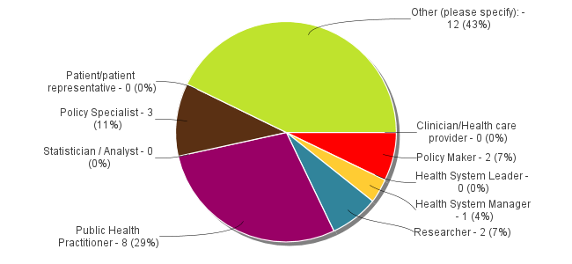

Question 1 What is your primary role? (Please check ONLY one) (Other (please specify):)
# | Response
1. | Municipal Planning
2. | transportation engineer
3. | Planning consultant
4. | Epidemiologist supporting policy
5. | Registered professional planner
6. | Coordinator-Seniors Safety Program
7. | University of Waterloo Planning Co-op student currently working with the City of Windsor Planning Department
8. | Planner
9. | Planner
10. | University instructor
11. | University instructor
12. | Land Use Planning

Question 2 In what type of organization do you work or volunteer? (i.e. for your primary role) (Please check ONLY one)
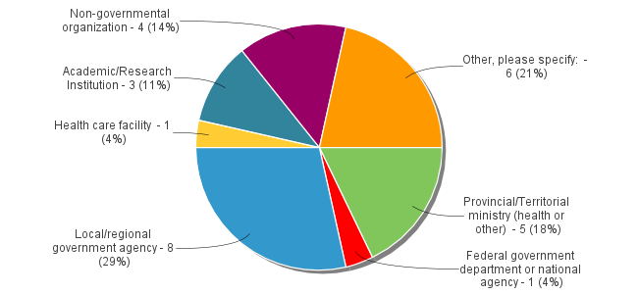

Question 2 In what type of organization do you work or volunteer? (i.e. for your primary role) (Please check ONLY one) (Other, please specify: )
# | Response
1. | public health
2. | Municipal government
3. | Private Consulting Firm
4. | Health Region
5. | district level Public Health
6. | Consultant - Land and Policy Development

Question 3 Within which jurisdiction does your primary organization undertake activities? (Please check ONLY one)
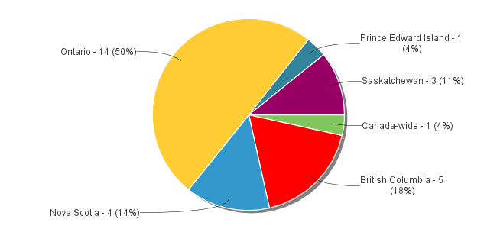

Question 4 The information presented at the webinar was:
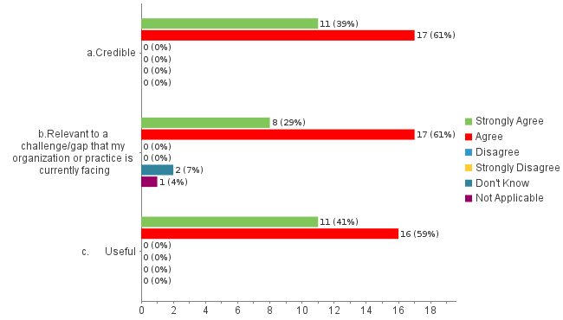

Question 5 The webinar was worth my time to attend
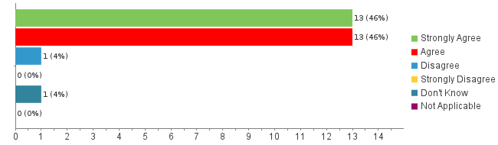

Question 6 During the webinar, I felt:
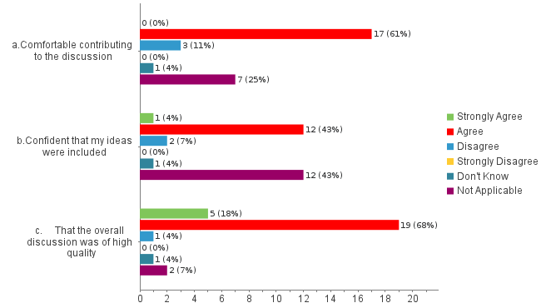

Question 7 As a result of attending the webinar, I plan to:
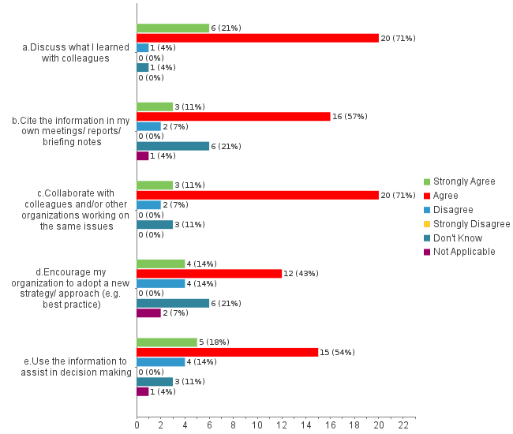

Question 8 How much collaboration is there between public health and transportation planners/engineers in your jurisdiction?
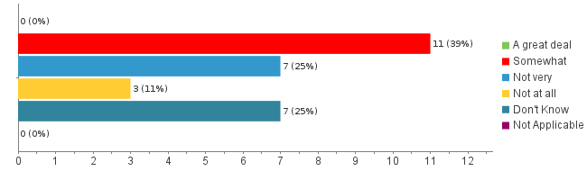

Question 9 How much collaboration is there between public health and land use planners in your jurisdiction?
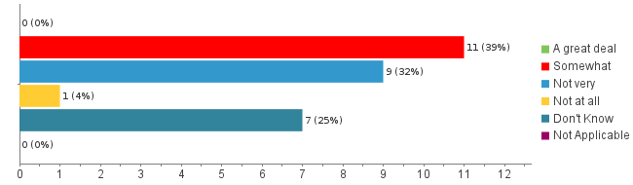

Question 10 Based on this webinar, how likely are you to increase collaboration between public health and land use or transportation planners in your jurisdiction?
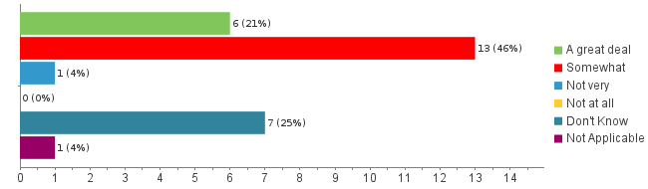

# | Response
1. | Your question wording is ambiguous, i.e., Does "you" refer to me as an individual or to us as an organization / jurisdiction? Either way, I am not directly involved in these matters at this time so do not know the answer.
2. | I think it would be good to increase collaboration and this webinar has given me some possible idea about how that can be done, and places I can go for more information.
3. | The webinar highlighted, among other items, the amazing work that can be accomplished through collaboration between public health and the various areas of planning.
4. | My role is to act as an advocate for senior's issues- this information will be useful at various committee meetings and as background knowledge for future discussions regarding Senior Friendly Communities.
5. | we are part of CLASP so are working to strengthen the collaboration
6. | Do not work in public health, while I can share the information with local municipalities to raise awareness public health locally seems to be more focused on maternal and infant health despite the changing population demographics.
7. | Even though I am working on this very topic, the work is very siloed and communication between project participants (e.g. public health & land planning) is not being facilitated by our leadership. Another example - I work in the same department that created the Healthy Development Index but I don't know what it is or the purpose.
8. | Hope to use the resources mentioned in a future project / practicum work with a health unit that is in early stages of built environment efforts.
9. | Academics can help foster these connections.
10. | Academics can help foster these connections.
11. | Private sector contact is virtually zero. Public sector health has inserted themselves into the planning/engineering which is great

Question 11 Please provide any other general feedback on the webinar:
# | Response
1. | I felt the speakers were all really good, I just did not learn anything new.
2. | It was excellent. It would be helpful to hear more about the modelling that people used to support decision-making and engage stakeholders, e.g., HEAT model.
3. | Thank you for providing these webinars! I find in Saskatchewan we have limited access to this information and limited funds to travel to conferences. Having access to these webinars that can be done from my desk has been such a valuable learning opportunity.
4. | Really pleased with the quality of the webinar and with the opportunity to learn about the amazing projects and initiatives underway across Canada specific to active transportation and healthy urban design.
5. | Dot was very friendly and efficient in her duties. This was my first webinar and I felt it was a generally positive experience.
6. | Great. Thanks you.
7. | Excellent session, demonstrating what is possible with focused attention.
8. | My colleagues and I found the Q&A portion of the webinar to be the most engaging. I find it easier to listen to a conversation for long periods of time as opposed to presentations, especially when the person presenting isn't physically present. Perhaps future webinars could take on a kind of interview format with a host asking guests questions or simply a longer Q&A period. Also, some of the slides could have been better organized to help keep people following along. Halifax did a great job creating visually pleasing and easy to follow slides. Overall though great information/conversation around an issue we need to talk more about.
9. | GREAT information. Very good presenters. Good quality slide decks. well coordinated.
10. | Great to learn of examples from medium sized - cites.
11. | Great to learn of examples from medium sized - cites.

